

# Visual Programming Final Project

## Professor: Alparslan Horasan

Prepared by:

Dania Ayad Al-Sultani (B2205.010035)

Nusaibah Mekkaoui (B2205.010015)

# Overview:

This document presents, in detail, how the program was designed and how it functions.

This program was created as an Airline ticket registration program used by employees of airline companies to collect data from passengers wishing to book a ticket for a flight. The data is collected using forms in an application connected to an SQL database, where the employees can not only manage and maintain the information collected, but also keep it safe.

# About the Program:

The program consists of three forms:

1. An Authentication Form
2. A Flight Details Form
3. A Record Form

# Authentication Form

Firstly, the employee is required to enter the username and password used to access the passenger information form.

## About the field:

The form consists of:

1. 3 labels (Authentication, Username, Password)
2. 2 text boxes (Username, Password)
3. 1 button (Login)

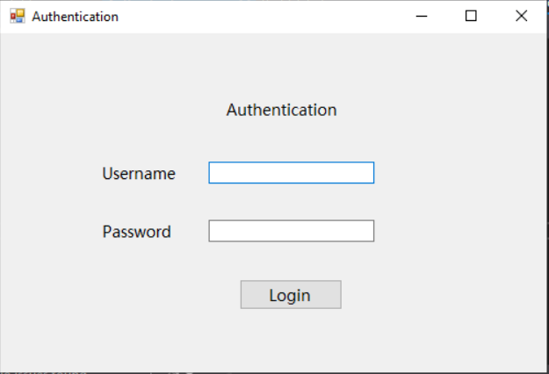

Upon entering the correct authentication credentials, the program will take the user to the second form, where the user will be able to enter the passenger’s flight details. However, if the credentials are incorrect, a message box will show up notifying the user of incorrect input of credentials and the user will have to re-enter the log in information.

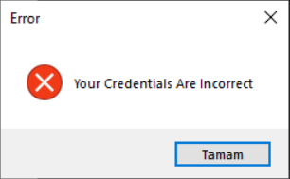

Entering the correct credentials will result in a message box notifying the user that he or she has successfully logged in.

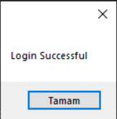

Secondly, the authentication form is connected to a table in the SQL database containing numerous usernames and passwords. This is done to allow different employees with different usernames and passwords to access the form and fill it out.

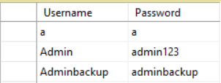

Once the correct credentials are entered and the user has successfully logged in, the “Flight Details” form will be displayed.

# Flight Details Form

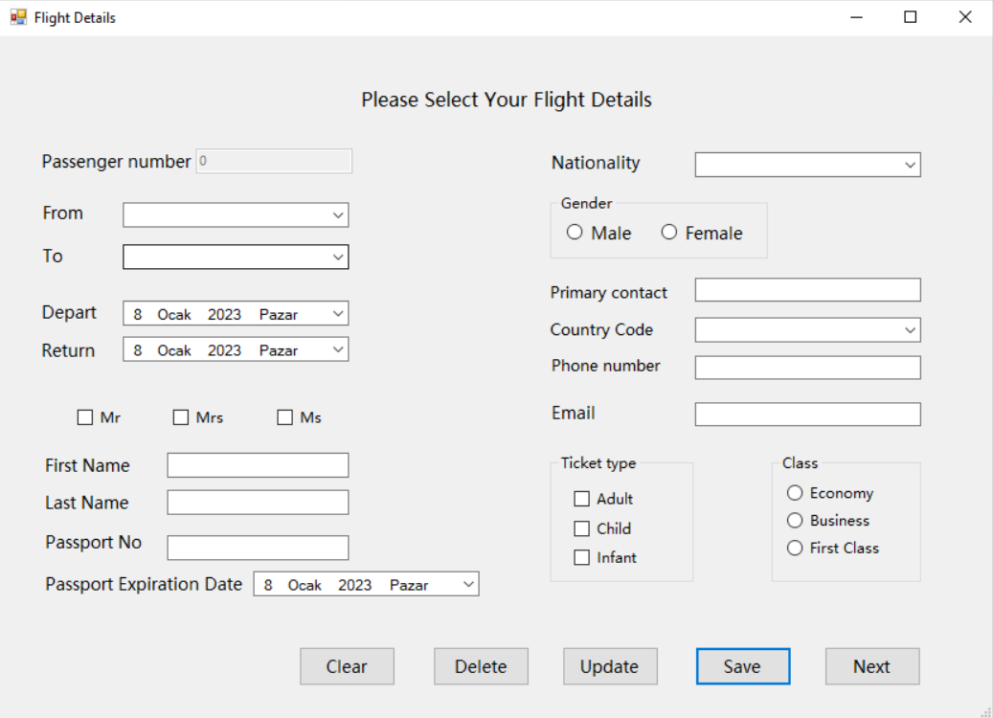The “Flight Details” form collects the passenger’s flight details.

Clicking the “Save” button will add the information to the Record form, where the data will be saved in a data grid view for the user to see and access.

Using the “Next” button will take the user to the next form where he or she will be able to access the data grid view. The “Clear” button will clear any data present in the current form.

## The Information to be collected in form 2:

1. Passenger’s Title (Mr./Mrs./Ms.)
2. Passport Number
3. Passport expiration date
4. First Name
5. Last Name
6. Gender
7. Nationality
8. Passenger’s primary Contact
9. Primary Contact’s Country Code
10. Primary Contact’s Phone Number
11. Primary Contact’s Email Address
12. City Travelling From
13. City Travelling to
14. Date of departure
15. Date of return
16. Ticket Type
17. Class

## About the field:

The form consists of:

1. Labels
2. Text boxes
3. Combo boxes
4. Buttons
5. Date time pickers
6. Check boxes
7. Group boxes
8. Radio buttons

The components for each type of information to be collected from the passenger.

* + Text box: passport number, first name, last name, passenger’s primary contact (a name), phone number, and email address.
  + Combo box: passenger’s nationality, country code, the city they’re travelling to, and the city they’re travelling from.
  + Date time picker: passport expiration date, date of departure and the date of return.
  + Checkbox: passenger’s title and ticket type.
  + Radio button: passenger’s gender and the flight’s class.

# Record Form:

This form is used to record and display the passenger’s flight information. Clicking on any row will take the user back to the “Flight Details” form where the information of that row will be displayed for the user to update or delete.

Warning: Should the user attempt to click the “Update” button without actually updating any information in the form, the program will crash. To avoid this problem, the user is required to re-enter the passenger’s gender when updating ANY information in record.

Attempting to delete any record will display a message box warning the user of deleting the selected record.

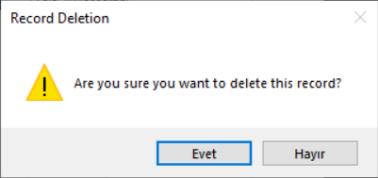

Should the user choose “Yes”, the record will be deleted and the user will be notified of the record being successfully deleted. However, if the user chooses “No”, the record will remain unchanged.

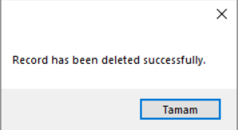

The user can also search for a specific passenger’s flight details by looking up the “Passenger Number” in the “Search” bar. Doing this will display only that passenger’s information in the data grid view.

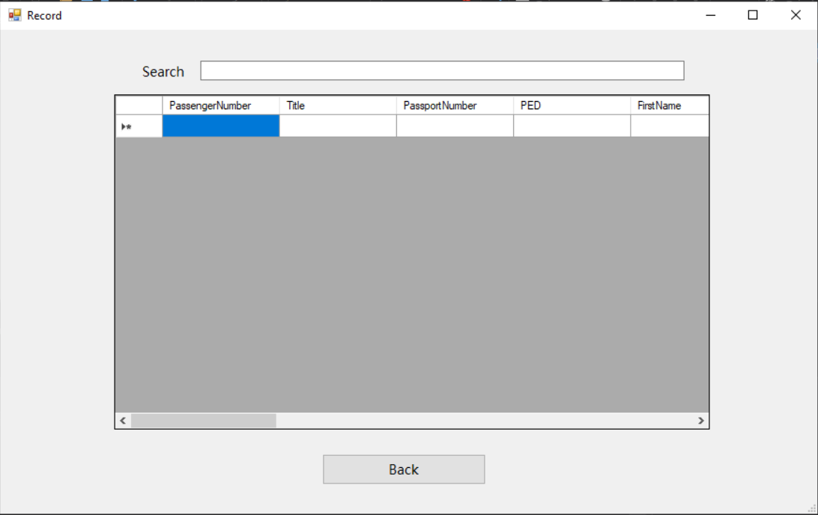

## About the field:

The form consists of:

1. Label (Search)
2. Text box (Search Box)
3. Data grid view (Record Table)

Saving the information in the Flight Details form (using the Save button) will display the passenger’s information in a table in the data grid view present in this form.

The data grid view in this form is also connected to a table in SQL database. This is done so that when the user inserts, deletes, or updates the passenger’s information in the data grid view, these same changes will also occur in the database’s table.

## About SQL:

The SQL database consists of two tables:

1. Login
2. PassengerInfo1

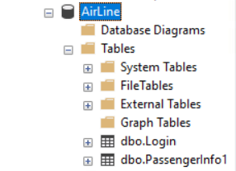

## Login Table:

The Login Table was created to serve a single purpose: to keep several usernames and passwords to allow several employees to enter and fill out the form.

### The columns that make up this table are:

1. Username
2. Password

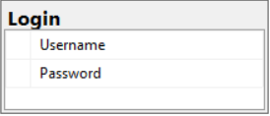

## PassengerInfo1 Table:

This table constitutes all the information the user needs to fill out in the form in order to book a ticket for the passenger.

The Passenger Number was set as a primary key, a unique identifier; being incremented each time a new ticket registration is processed.

### The columns that make up this table are:

1. Passenger Number
2. Title
3. Passport Number
4. Passport Expiration Number (PED)
5. First Name
6. Last Name
7. Gender
8. Nationality
9. Primary Contact
10. Country Code
11. Phone Number
12. Email
13. City From
14. City To
15. Depart Date
16. Return Date
17. Ticket Type
18. Class

